Curriculum Vitae

AINO FAVÉN

Visual artist

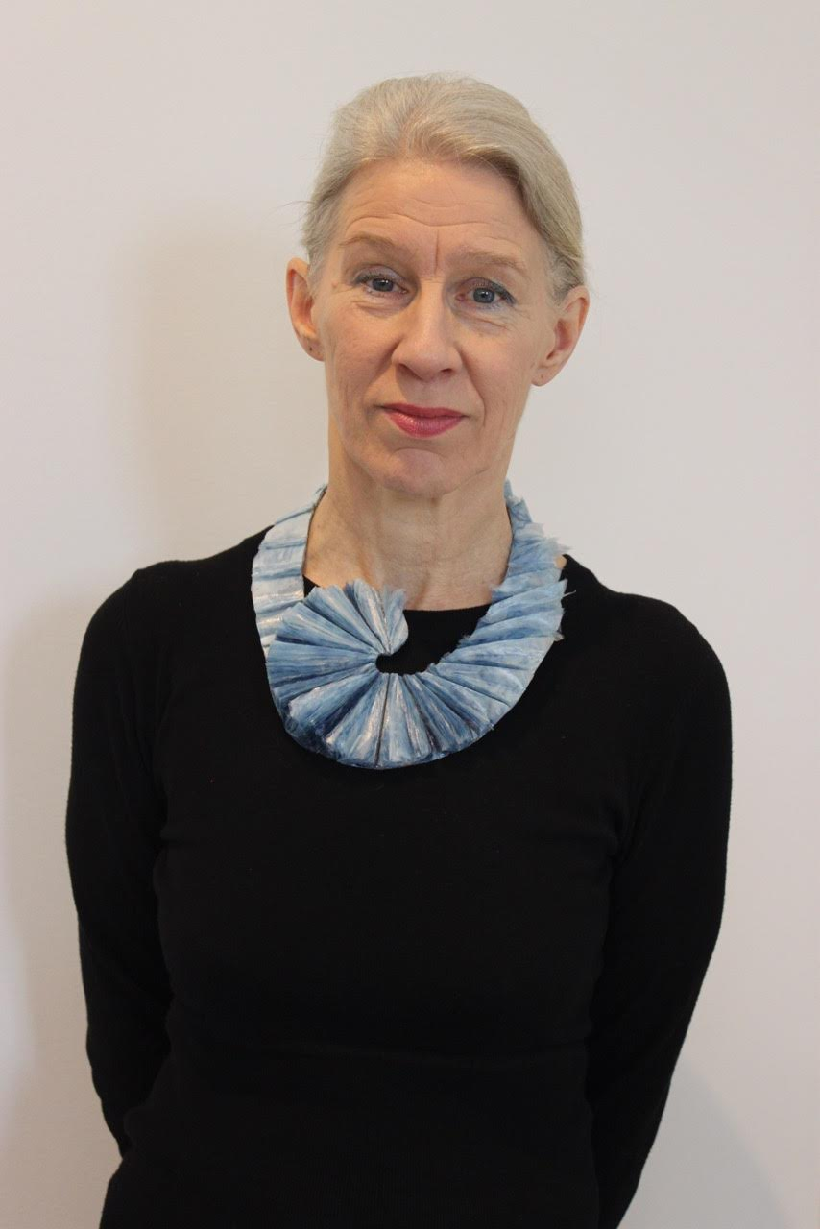

As a textile and jewellery artist Aino Favén has often used recycled materials, particularly plastic. Not just because the plastics should be reused, but also because she is fascinated by how a grubby plastic bag or a bottle can be transformed into something magical, soft and translucent.

"Much of our waste today is plastic, made of petroleum, is a material that the earth cannot digest. Every bit of plastic that has ever been created still exists, except for a small amount that has been incinerated, releasing toxic chemicals. In the oceans, plastic waste converges in swirling seas of garbage. The production of plastic objects, wraps and containers is not decreasing. I think the best designers could do is to design long lasting things timeless in form and durable in use."

Education
1985 M.A. University of Art and Design, textile art, Helsinki, Finland,

Honors
2012-2021 Artist Professor Nomination, State of Finland

Selected private exhibitions

2025 Our Plastic world, Kanneltalo Gallery, Helsinki Finland
2024 Colour Tunings, Merirasti, Helsinki, Finland
2018 Birds, birds, Galleria Lennätin, Harakka Island, Helsinki, Finland
2016 GallerygalleryEX, Kyoto, Japan
2015 Tern road, O gallery Helsinki, Finland
2010 Afloat, Galleria Johan S., Helsinki, Finland
2009 Boats and sea views, Harakka Island, Helsinki, Finland
2005 Certain metamorphoses, Design Forum Finland, Helsinki, Finland
2003 Oevres de Ombre et de Lumiere, Centre Culturel Finlandaise, Antwerpen, Belgium
2003 Fiberscapes, Contemporary Textile Art from Finland Ottawa City Art Gallery, Canada
2002 Fiberscapes, Embassy of Finland, Washington, DC USA
2000 ARS Rauma 2000, Rauma Art Museum, Finland
1999 Nature Works , Galleria Bau, Helsinki
1997 Land, Sea and Air, Galleria Bau, Helsinki
1991 Galleri Metallum, Stockholm, Sweden
1990 Kluuvi Gallery, Helsinki, Finland
1988 Galleria 585, Helsinki, Finland
Selected group exhibitions

2020 Stadionnäyttely, Olympic Stadium, Helsinki Design Week
2020 Outshining Darkness @gaoshanhelsinki, virtual exhibition
2019 Garden of Eden, European Textile Network, Haslach, Austria
2019 Northern Lights, CODA Museum, Apeldoorn, Netherland
2017 LOOT - Mad about Jewelry, Museum of Art and Design, New York
2015 Valo-Ljus-Lumière, Gumbostrand Konst & Form, Sipoo, Finland
2013-15 Shop Show Form Design Center, Malmö , Sweden
2013-15 From the Coolest Corner , Nordic Jewellery, Oslo, Kööpenhamina, Helsinki, Tallinna, Göteborg, Munchen
2012 Oasis, Kuparipaja, Fiskars, Finland
2011 Cheongju Craft Biennale, South Korea
2011 OON kaupungissa – City art event, Kalasatama metro station , Helsinki
2010 Climate Change in Contemporary Art, Joensuu Art Museum, Finland
2009 Askel maisemaan, Halosenniemi Museum, Tuusula, Finland
2008-09 Otto, Vantaa Art Museum, Finland
2006 Hands and All, Amos Anderson Art Museum, Helsinki, Finland
2002 Finndesignnow, Design Forum, Helsinki
2001 Lodz International Textile Art Biennial, Poland
1999 Die Farbe Blau - eine kulturelle Brücke, Textilmuseum Neumünster, Germany
1999 Textile Triennial 5, Design Museum, Helsinki
1998 Gallery Space 21, Tokyo, Japan
1998 ETN textile art exhibition, Madrid, Spain
1997 Triennale International de Tournai, Belgium

Collections
State Art Collection, Finland
Salo Art Museum, Finland
Design Museum, Helsinki, Finland
Congregation of Kauniainen, Finland
Deedie Rose Collection, Dallas, Texas
Dallas Art Museum, Dallas, USA
Pahlman Collection, Espoo, Finland
Collection Efharis Alepedis, Boston, USA
Tuomo Sopanen ryijy-rug collection, Varkaus, Finland

Public works
Church of Kauniainen, Finland
Sebastos Chapel, Kauniainen, Finland
Population Register Centre, Helsinki, Finland
Salo Fire Station, Salo, Finland
Housing Company Kivikonkaari, Helsinki, Finland
Housing Company Veturitallinpuisto, Jyväskylä, Finland
Nursery School of Kirkonseutu, Valkeala, Finland
Valkeala Swimming Hall, Finland
Jorvi Hospital, Espoo, Finland
Competitions

2019 Metsäkaltevatalo, Hyvinkää, Finland, public art competition, 2nd prize
2013 Church Textiles of Kauniainen; 1st prize
2008 Church Textiles, Espoo Congregation, Finland; Redemption Award
1990 Christal Lightning Competition, Vienna, Austria; Redemption Award
1985 Church Textiles, Congregation Concern of Helsinki, Finland; Redemption Award

Contact and media:

address: Juhannusruusunkuja 3A11, 00990 Helsinki
tel. +358-50-5010348
e-mail: faven.aino@gmail.com

http://www.finnishdesigners.fi/portfolio/aino.faven
recycledart.fi/faven

https://facebook.com/favenaino
instagram: @favenaino

